**Accommodation**

There are several hotels located close to the city center within walking distance of the conference venue at Campus WU.

**Bassena Wien Messe Prater** - 1 min. walking distance to Campus WU  
Messestraße 2, 1020 Vienna  
[Website](https://bassenahotels.com/en)

**Motel One Wien-Prater** - 6 min. walking distance  
Ausstellungsstraße 40, 1020 Vienna  
[Website](http://www.motel-one.at/)

**Courtyard Marriott Wien-Messe** - 1 min. walking distance  
Trabrennstraße 4, 1020 Vienna  
[Website](https://www.marriott.com/hotels/travel/viefg-courtyard-vienna-prater-messe/)

**Hampton by Hilton Vienna Messe** - 2 min. walking distance  
Perspektivstraße10, 1020 Vienna  
[Website](https://www.hilton.com/en/hotels/vienahx-hampton-vienna-messe/)

**Superbude Wien Prater** - 2 min. walking distance  
Perspektivstraße 8, 1020 Vienna  
[Website](https://www.superbude.com/hotel-wien/prater)

**Public Transport and Travel**

Get to Vienna

**By train**

Vienna is well-reachable by train and overland busses. Long-distance trains stop at the Vienna Main Station (Hauptbahnhof), local and private trains also at Wien Westbahnhof or Wien Mitte. The national railway company is ÖBB.

**By plane**

Most of the international airlines will bring you to [Vienna International Airport VIE](https://www.viennaairport.com/en/passengers). The airport is around 20km from the city center but is well-connected with public transport. Please note that you will need an additional ticket as Vienna’s public transport does not cover this route. You have several options to get from the airport to the center:

**Local Train S7**

An easy option to reach the city is the suburban railway S7. Trains depart from the airport approximately every 30 minutes. The journey to the two most central stops, Wien-Mitte or Praterstern, takes about 20-25 minutes. Tickets for €4.40 can be purchased in the ÖBB app or at the vending machine at the airport.

**City Airport Train**

The CAT also runs every 30 minutes between the airport and Wien-Mitte station. The journey takes approx. 16 minutes. Tickets for €14.90 (one-way) or €24.90 (return) can be purchased at the green vending machine at the airport.

**Airport bus**

In addition, the city center can be reached within approx. 20 minutes via the Morzinplatz/Schwedenplatz bus stop. The buses run every 30 minutes.

**Public Transport**

Vienna has a fast and well-developed [public transport network](https://www.wienerlinien.at/web/wl-en), including subway, trams, busses, and railways, making traveling around the city convenient.

Depending on your stay, you can buy tickets for single rides, 24 hours, 48 hours, 72 hours, one week, or longer. Tickets are sold in the entry area of subway stations, in the [online shop of Wiener Linien](https://shop.wienmobil.at/en/products), or the [WienMobil app](https://www.wienerlinien.at/web/wl-en/wienmobil-enjoy-mobile-freedom).

Please note that if you travel by subway, you must purchase and punch your ticket before you enter the platform area. If you travel by bus or tram, you can buy and punch it in the vehicle.

**How to get to WU Vienna**

The GEM&L conference will take place in the AD building on WU campus. Please use our [interactive campus map](https://campus.wu.ac.at/) to find your way around the campus.

**Address**

Vienna University of Economics and Business

Welthandelsplatz 1,

1020 Vienna

**By Public Transport**

**Subway**

Campus WU is located between the two U2 [subway](https://www.wienerlinien.at/web/wl-en) stations Messe-Prater and Krieau. The Library & Learning Center (LC) is roughly the same distance from each of the two subway stations (5–10 minutes walking). The station Messe-Prater is closer to the building D5. However, you can use the chance to explore our campus on a little walk:

To access Campus WU from the west (WU Executive Academy, Administration, Department Buildings 3, 4, and 5, Library & Learning Center), please use the U2 subway station Messe-Prater, exit Messe.

To access Campus WU from the east (Teaching Center, Student Center, Department Buildings 1 and 2, Library & Learning Center), please use the U2 subway station Krieau, exit Krieau.

**Tram**

Another convenient way to reach Campus WU is by tram line 1. Get off at the final stop, Prater Hauptallee, in the public park Prater. After a short walk (5-10 minutes) through the idyllic park, you can access Campus WU.

**Bus**

Bus line 82A, stations Krieau, Trabrennstraße, Südportalstraße, or Welthandelsplatz, will bring you close to Campus WU.

**By Walking or Biking**

You can also reach Campus WU on foot. It is about a 40-minute walk from the city center, but numerous surrounding places and sights are in the immediate vicinity and can be easily explored on foot. For example, the surrounding train stations: Praterstern (15min walk) or Wien-Mitte (30min walk).

Campus WU is located next to the park Prater, which is an ideal spot for a relaxing stroll before or after the conference.

Using [“WienMobil Rad”-bikes](https://www.wienerlinien.at/web/wl-en/wienmobil-rad-bikesharing) is not only a good option for getting around the city, but also for reaching Campus WU: there are multiple bike-sharing stations around.

**By Car**

Campus WU has its own underground parking garage with an entrance on Trabrennstraße. Please note, however, that there is a charge for using it.

**At the Conference**

The GEM&L conference 2025 will be held at the [Vienna University of Economics and Business](https://www.wu.ac.at/en/) (WU Vienna), Welthandelsplatz 1, 1020 Vienna.

The Vienna University of Economics and Business is a leading academic institution and one of Europe’s most attractive universities in the fields of business and economics. True to its role as an open-minded institution, WU also sees itself as an international university, as an important hub for global exchange, and as a place where students and teachers work together. Open-mindedness and diversity were already among the university’s key values at the time of WU’s founding in 1898.

**Registration and Information Desk**

The registration desk will be located on the ground floor of the AD building. We will be there for you during the entire conference.

**On Campus**

The campus has an amazing infrastructure. The entire campus is barrier-free: all paths and rooms are wheelchair-accessible. It offers a broad and diverse selection of dining options with numerous cafes, restaurants, and a supermarket. There is an ATM located next to the “Mensa” cafeteria and in the “Spar” supermarket. Vienna has some of the best tap water in the world – you can refill your water bottle anytime.

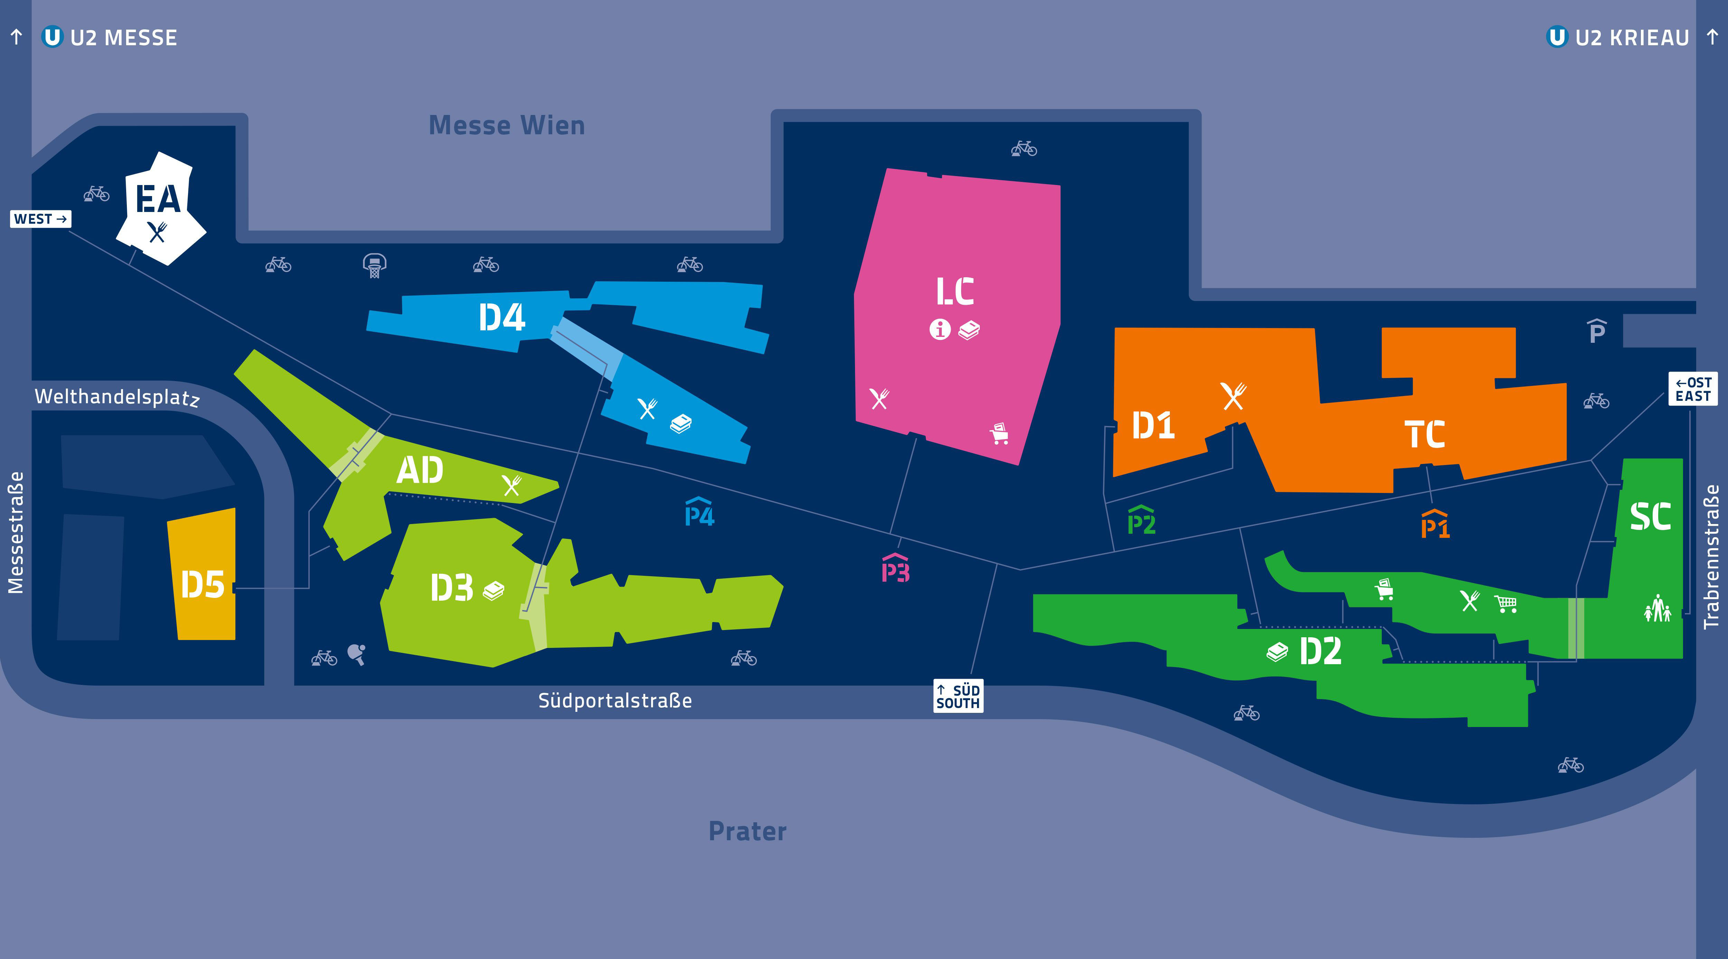

Vienna tourism info

Various topics: <https://meeting.vienna.info/en/why-vienna/further-information-vienna>

General info about Vienna: <https://www.wien.info/en/travel-info/tourist-info/general-information-346750>

Travel info: <https://meeting.vienna.info/en/why-vienna/traveling-to-vienna>

Viennese cuisine: <https://www.wien.info/en/dine-drink/viennese-cuisine>

Coffee houses: <https://www.wien.info/en/dine-drink/coffeehouses>

Wine: <https://www.wien.info/en/dine-drink/wine>

Art & Culture: <https://www.wien.info/en/art-culture>

Museums & exhibitions: <https://www.wien.info/en/art-culture/museums-exhibitions>

Imperial sights: <https://www.wien.info/en/art-culture/imperial-sights>

Sights from A to Z: <https://www.wien.info/en/see-do/sights-from-a-to-z>